Session 10: Advanced User-Defined Functions
1. Objective
To create custom logic for financial calculations and user categorization using dynamic tax slabs and experience-based classification.

2. Implementation Queries
First, we need to add an experience and salary column to your Student table to make these functions work for your documentation.
ALTER TABLE Student ADD COLUMN salary INT DEFAULT 0;
ALTER TABLE Student ADD COLUMN years_exp INT DEFAULT 0;
UPDATE Student SET salary = 450000, years_exp = 3 WHERE VTU_Number = 'VTU001';
UPDATE Student SET salary = 1200000, years_exp = 12 WHERE VTU_Number = 'VTU002';
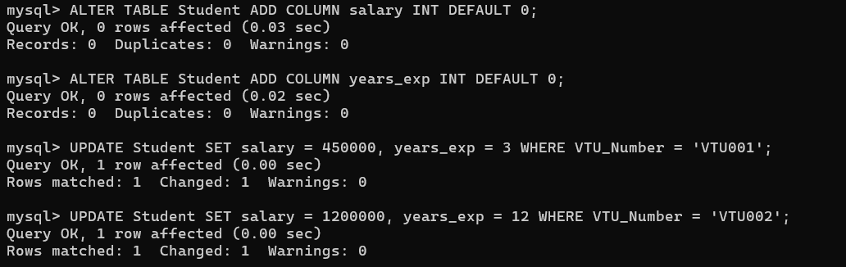
Task 1: Dynamic Tax Slab Calculation
This function calculates the tax amount for a student (or employee) based on their salary range.
DELIMITER //
CREATE FUNCTION GetTaxAmount(sal INT)
RETURNS FLOAT
DETERMINISTIC
BEGIN
IF sal < 300001 THEN RETURN 0;
ELSEIF sal <= 600000 THEN RETURN sal * 0.10;
ELSEIF sal <= 1000000 THEN RETURN sal * 0.20;
ELSE RETURN sal * 0.30;
END IF;
END //
DELIMITER ;
SELECT Name, salary, GetTaxAmount(salary) AS Tax_Deduction FROM Student;
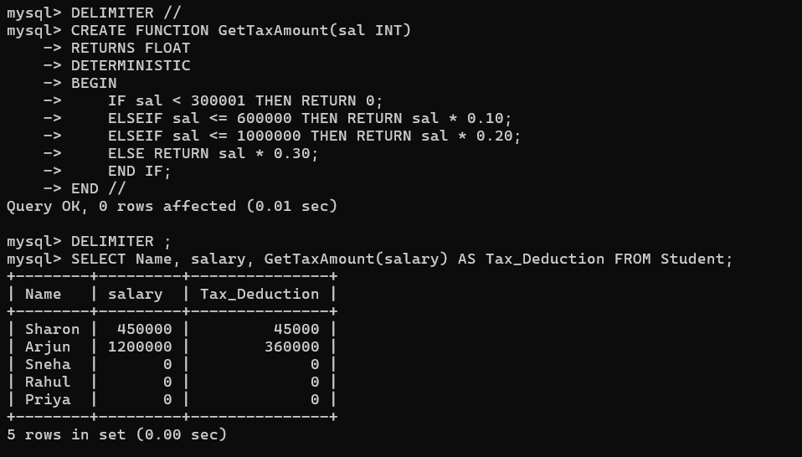
Task 2: Experience Categorization
This function labels students as Fresher, Junior, Mid, or Senior based on their years in the field.
DELIMITER //
CREATE FUNCTION CategorizeExperience(yrs INT)
RETURNS VARCHAR(20)
DETERMINISTIC
BEGIN
IF yrs < 2 THEN RETURN 'Fresher';
ELSEIF yrs <= 5 THEN RETURN 'Junior';
ELSEIF yrs <= 10 THEN RETURN 'Mid';
ELSE RETURN 'Senior';
END IF;
END //
DELIMITER ;
SELECT Name, years_exp, CategorizeExperience(years_exp) AS Category FROM Student;
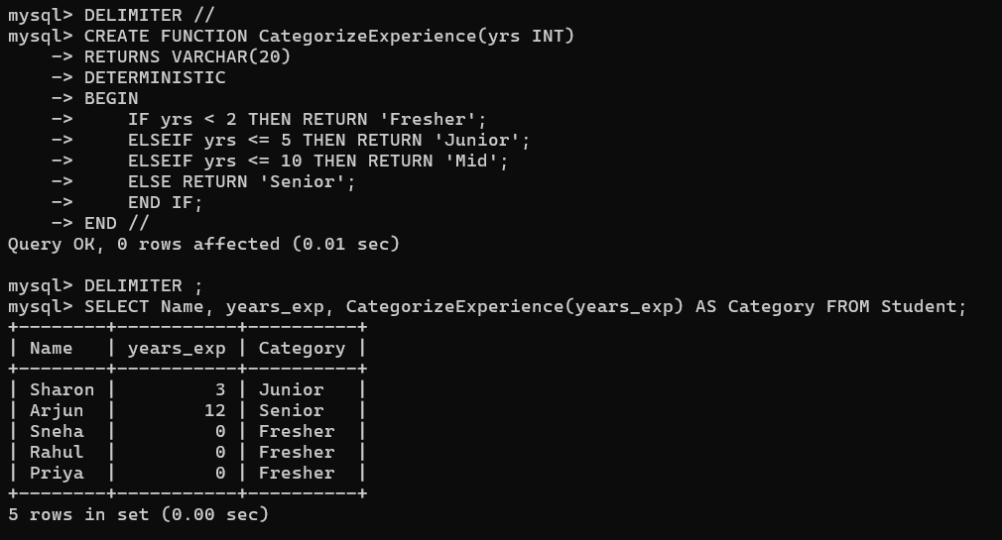
Task 3: Late Fee Calculator
For Project-Hub, this calculates a late fee of 250 per day (capped at 1000) if a student submits after the due date.
DELIMITER //
CREATE FUNCTION CalculateLateFee(days_late INT)
RETURNS INT
DETERMINISTIC
BEGIN
DECLARE total_fee INT;
SET total_fee = days_late * 250;
IF total_fee > 1000 THEN SET total_fee = 1000;
END IF;
RETURN total_fee;
END //
DELIMITER ;
SELECT CalculateLateFee(3) AS Fee_For_3_Days;
